**Домашнее задание № 8**

1. Установите последние версии следующих браузеров на свой компьютер: Mozilla FireFox, Opera, Google Chrome, Internet Explorer, Safari.

Бентси) Пожалуйста, не хочу захламлять систему кучей ненужного софта. Можно засчитать условную установку?)

1. Сформулируйте суть бага на рисунке.

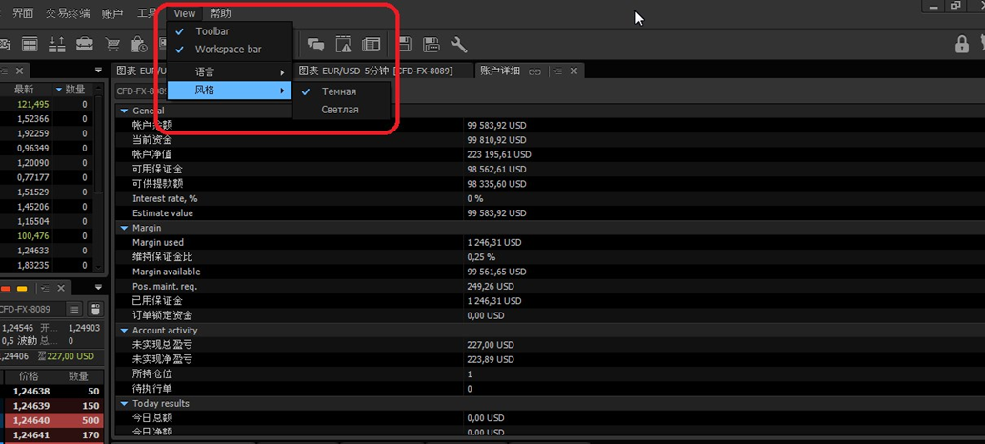

Bag report

|  |  |
| --- | --- |
| Summary | Localization error: when using English, part of the text is displayed as hieroglyphs |
| Project | «А» |
| Application component | Dark design |
| Number version | - |
| Severity | Major |
| Priority | - |
| Status | - |
| Autor | Reznikov Roman |
| Assigned to: | - |
| Steps to reproduce | 1. Open program N Version N. |
| Expected result | When using English, the text is displayed correctly, without errors and third-party characters other than punctuation marks. |
| Actual result | The description of fields contains third party characters and hieroglyphs that are not related to the English language punctuation marks. |

1. Сформулируйте и опишите все баги, которые вы видите на рисунке.

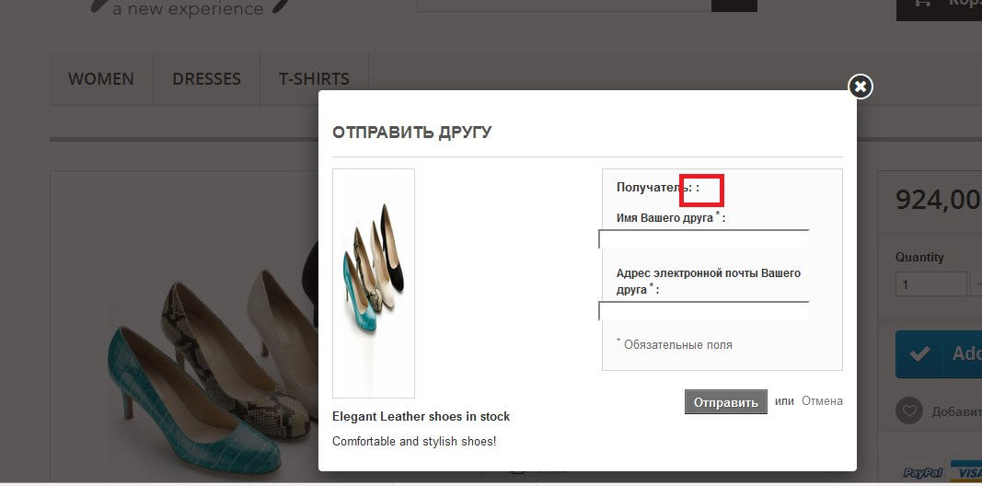

**Bug one**

|  |  |
| --- | --- |
| Summary | The product image is strongly compressed horizontally, the image is distorted. There is no centralization. |
| Project | «В» |
| Application component | Sending an item to a friend |
| Number version | - |
| Severity | Minor |
| Priority | - |
| Status | - |
| Autor | Reznikov Roman |
| Assigned to: | - |
| Steps to reproduce | 1. Go to the site N  2. Go to the women's shoes section  3. Choose shoes  4. Open the tab "gift to a friend» |
| Expected result | The product image is located to the left of the center, there is no distortion. |
| Actual result | The product image is distorted and strongly shifted to the left. |

**Bug two**

|  |  |
| --- | --- |
| Summary | There is no input field: Recipient. |
| Project | «В» |
| Application component | Sending an item to a friend |
| Number version | - |
| Severity | Major |
| Priority | - |
| Status | - |
| Autor | Reznikov Roman |
| Assigned to: | - |
| Steps to reproduce | 1. Go to the site N  2. Go to the women's shoes section  3. Choose shoes  4. Open the tab "gift to a friend» |
| Expected result | The window should contain three input fields: Recipient, Your friend's name, and your friend's email address. |
| Actual result | There is no "Recipient"input field. |

**Bug three**

|  |  |
| --- | --- |
| Summary | The frame that highlights the block of information about the recipient is shifted. |
| Project | «В» |
| Application component | Sending an item to a friend |
| Number version | - |
| Severity | Minor |
| Priority | - |
| Status | - |
| Autor | Reznikov Roman |
| Assigned to: | - |
| Steps to reproduce | 1. Go to the site N  2. Go to the women's shoes section  3. Choose shoes  4. Open the tab "gift to a friend» |
| Expected result | The block for entering data about the recipient is designed without distortion or bias. |
| Actual result | The frame that highlights the block for entering data about the recipient is shifted to the right side. |

1. Опишите ошибку на видео:

<https://drive.google.com/file/d/0B_SXnmXVP6nNYkVDMTV1Njd3aUU/view?usp=sharing>

|  |  |
| --- | --- |
| Summary | Visual error. The cursor disappears. |
| Project | «С» |
| Application component | - |
| Number version | - |
| Severity | Minor |
| Priority | - |
| Status | - |
| Autor | Reznikov Roman |
| Assigned to: | - |
| Steps to reproduce | 1.Go to the site www.prestashop.com  2.Go to the women's products section  3.Choose shorts  4.Hover the cursor over the social icons. Networks. |
| Expected result | All page elements are displayed |
| Actual result | The cursor becomes invisible when hovering over social network icons |